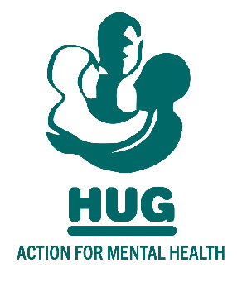

On 25th May 2018 new data protection rules came into force. This means that we need you to confirm you wish to receive information from HUG (Action for Mental Health), who come under the umbrella of SPIRIT Advocacy. If you have any questions or no longer wish to remain on our database, please contact dataprotection@spiritadvocacy.org.uk

Forename

Surname

Email address

Telephone (landline or mobile)

Organisation (if applicable)

Consent (Please tick ONE box)

I agree to HUG (Action for Mental Health) storing my data and using it to communicate with me

I do not agree to HUG (Action for Mental Health) storing my data and using it to communicate with me, and understand all data currently held will be deleted

PLEASE RETAIN THIS SLIP FOR YOUR RECORDS

Thank you for signing up to the HUG Database. We will use your information to send you relevant communications about HUG and our activities.

You can update your contact preferences, or ask to be removed from our database
at any time by contacting:

dataprotection@spiritadvocacy.org.uk

